

Mini Project Report
of
Database Systems Lab (CSS 2212)

TITLE

SUBMITTED
BY

STUDENT NAMEs REG. NOS, ROLL NOS, SECTIONS

School of Computer Engineering
Manipal Institute of Technology, Manipal.
April 2026

SCHOOL OF COMPUTER ENGINEERING

Manipal
00/00/2026

CERTIFICATE

This is to certify that the project titled MiniProject Title is a record of the bonafide work done by Student(s) (Reg. No. 000000) submitted in partial fulfilment of the requirements for the award of the Degree of Bachelor of Technology (B.Tech.) in ------------------ENGINEERING of Manipal Institute of Technology, Manipal, Karnataka, (A Constituent Institute of Manipal Academy of Higher Education), during the academic year 2025-2026.

Name and Signature of Examiners:

- Dr. Anup Bhat B, Assistant Professor, SCE.

- Dr. ….., …., SCE.

ABSTRACT

Good abstract to be written.

At the end add ACM taxonomy (You can search and write the keywords related to your project)
For example:
[Security and Privacy]: Cryptography management; Access Control; Symmetric Cryptography;

Write the suitable Sustainable Development Goal (There are about 17 SDGs proposed by Govt of India) to which your project belongs to (Please get the development goals from the Govt of India website)
For example:
[SDG]: Quality Education

Table of Contents

List of Tables

List of Figures

Abbreviations

Chapter 1

Chapter Title

This is an introduction chapter.
  - Section 1
This section is 1.1 and it describes the aspects of Introduction [1].

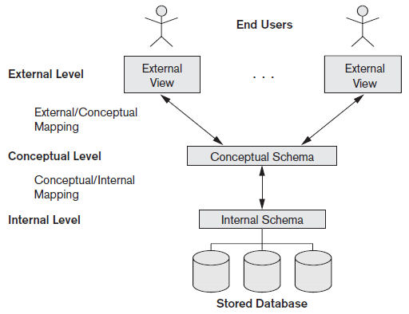

Figure 1.1: Three Tier Architecture

Chapter 2

Chapter Title

2.1 Section 1

References
[1] Y. Okada, K. Dejima, and T. Ohishi, \Analysis and comparison of PM synchronous motor and induction motor type magnetic bearings," IEEE Trans. on EE, vol. 31, pp. 1047{1053, Sep./Oct. 1995.

Specifications to be followed:
- Font size: 12 for regular text, font size: 14 for side headings and font size: 26 for chapter numbers and title
- Font Type: Times New Roman
- Text alignment: Justified (Both Sides)
- Line spacing 1.25 or 1.5
- References to be put in IEEE format
For further clarifications, contact the faculty.
Note: Ensure that you have the following chapters included.
CHAPTER 1: INTRODUCTION

CHAPTER 2: PROBLEM STATEMENT & OBJECTIVES – specify the details of the miniworld, the need for database. In Objectives, list the requirements that this database application implements. Elaborate the requirements as appropriate.

CHAPTER 3: DATABASE DESIGN –
i. Based on the objectives listed in the previous chapter illustrate the ER Diagram. The diagram must be clear with proper resolution. You can choose to draw the diagram adhering to the notations followed in the syllabus using any online tools or a clear photo of hand drawn diagram may also be attached.
ii. Clearly show the steps reducing the diagram to database schema
iii. Discuss design alternatives and normal form of the derived schema in detail. In case the implementation follows a different schema highlight it clearly here with necessary justifications

CHAPTER 4: DDL COMMANDS & PL/SQL PROCEDURES / FUNCTIONS / TRIGGERS -
Provide the commands for creating the tables, inserting sample data (two rows per table), different queries written to achieve the functionality along with various PL/SQL procedures

CHAPTER 5: RESULTS & SNAPSHOTS- Screenshot of the UI developed

CHAPTER 6: CONCLUSION, LIMITATIONS & FUTURE WORK

CHAPTER 7: REFERENCES

